1.Area of Rectangle:
Pseudo Code:
BEGIN
READ l,b
CALCULATE A=l*b
DISPLAY A
END
Algorithm:
Step 1: Start
Step 2: get l,b values
Step 3: Calculate A=l*b
Step 4: Display A
Step 5: Stop
Flowchart:
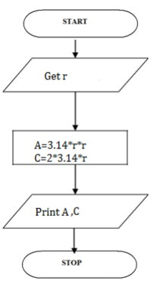

2.To check greatest of two numbers:
Pseodo Code:
BEGIN
READ a,b
IF (a>b) THEN
DISPLAY a is greater
ELSE
DISPLAY b is greater
END IF
END

Algorithm:
Step 1: Start
Step 2: get a,b value
step 3: check if(a>b) print a is greater
Step 4: else b is greater
Step 5: Stop

Flowchart:
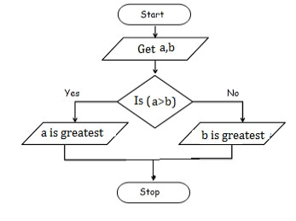

3.To check odd or even number:
Pseudo Code:
BEGIN
READ num
IF (num%2==0) THEN
DISPLAY num is even
ELSE
DISPLAY num is odd
END IF
END

Algorithm:
Step 1: Start
Step 2: get num
Step 3: check if(num%2==0) print num is even
Step 4: else num is odd
Step 5: Stop

Fowchart:
